Components that need attention
Footprint | DO214AC_SMA | TAJD_AVX | LED0603 | HARWIN_M55-7002642R | DRV0006A | RPW0010A-MFG
Reference | D1, D3, D5 | C2,C5, C9, C13, C14, C15 | D2, D4, D6 | J2 | U6, U7, U8 | U1, U3, U5
Silk screen draw | 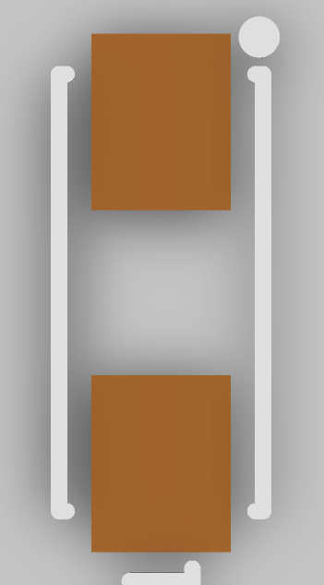 | 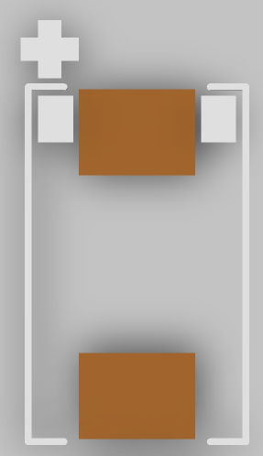 | 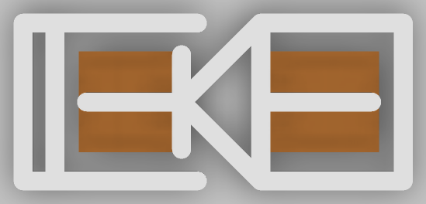 | 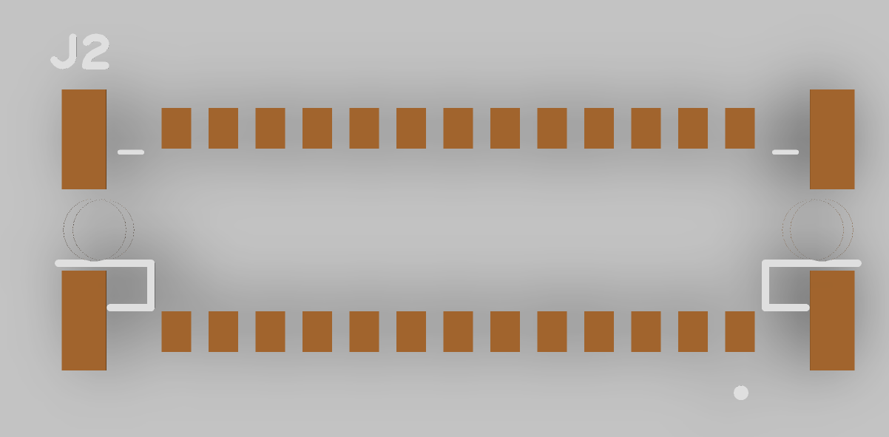 | 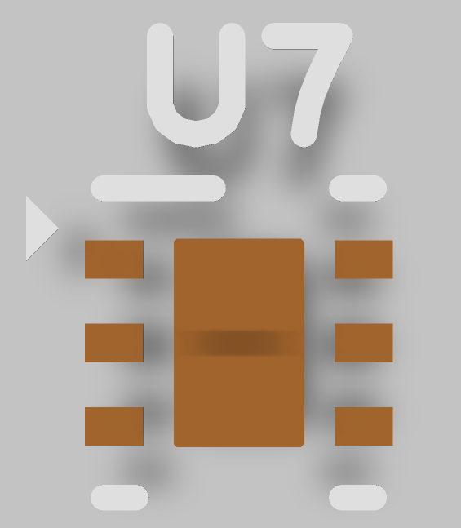 | 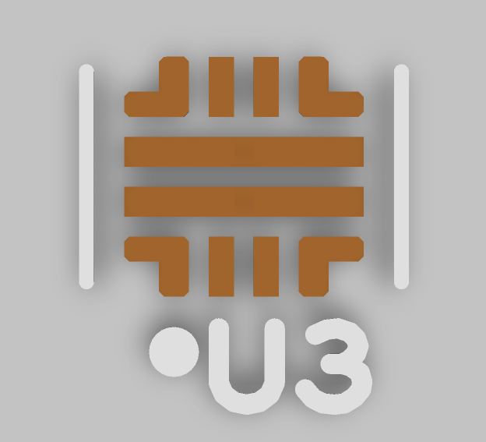
3D | 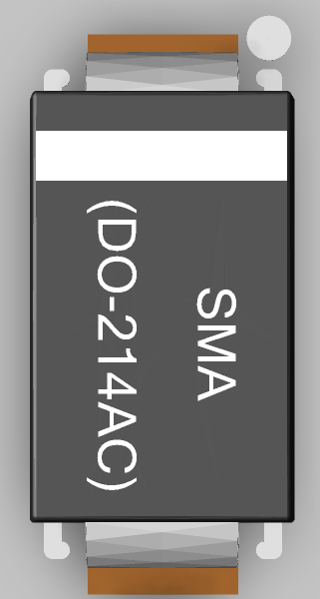 |  | 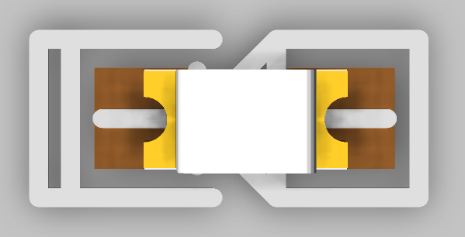  Anode (+)  Cathode  (-) | 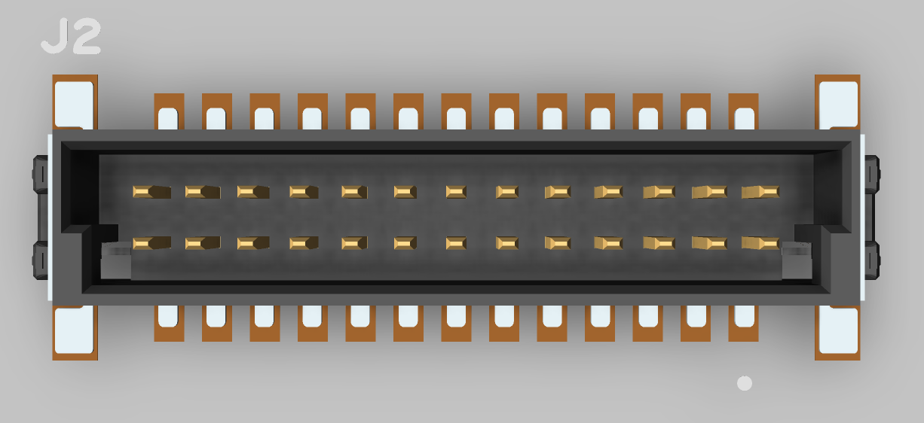 | 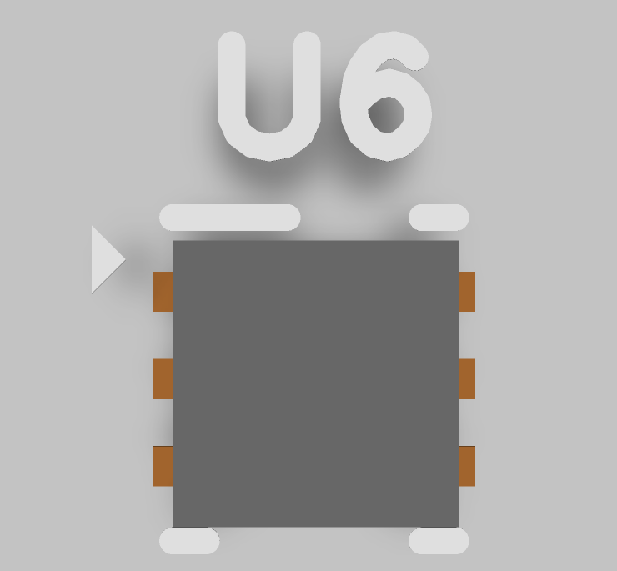 | 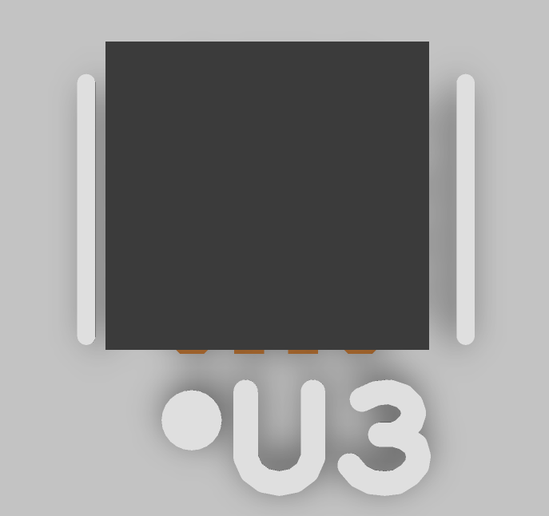
Note | Dot mark (.) is Cathode (-) | The plus mark (+) is positive of the capacitor. |  | The ridge of the connector is aligned with the direction of the dot mark (.) | The mark (>) is pin 1st. | Dot mark (.) is pin 1st.

